OS&D
REMINDER OF THE WEEK
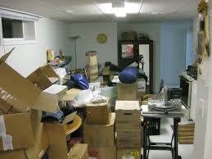
DOES YOUR OS&D BAY LOOK LIKE THIS?
OVER/REFUSED AND UNIDENTIFED FREIGHT SHOULD BE CLEARED UP EVERYDAY. ALTHOUGH SOMETIMES IT TAKES A FEW DAYS TO OBTAIN DISPO OR TO MATCH OVER FREIGHT UP TO A SHORTAGE, NOTHING SHOULD REMAIN IN YOUR OS&D FOR AN EXTENDED TIME PERIOD.
ITEMS SHOULD NOT REMAIN IN YOUR BAY AREA FOR MORE THAN 1 WEEK. FREIGHT IS PLACED ON-HAND AFTER 5 DAYS OF YOUR FIRST REQUEST FOR DISPO. FREIGHT WITH DISPO IS SENT TO STP-SALVAGE.
PHOTOS OF UNIDENTIFIED FREIGHT THAT CAN NOT BE MATCHED UP AFTER 3 DAYS CAN BE SENT TO THE CLAIMS DEPARTMENT FOR HELP. KEEP YOUR AREA CLEAN. DO NOT STORE OS&D FREIGHT IN TRAILERS.
